Designing a MicroSupply

|  |  |
| --- | --- |
| Author | Toon De Leersnyder |

Content

1 Material and methods 1

2 Results 6

2.1 functionality 6

2.1.1 Block diagram 6

2.1.2 Electric scheme 7

2.2 usage 8

2.2.1 functions 8

3 Discussion 9

4 Reference list 10

Introduction

[Describe your project:

* What did you build?
* What are the main characteristics of the device?
* What does it do?
* What is the reason you chose to build this device?
* What is your starting point? Are there any (scientifically-) related articles you used?
* Give an overview of the different topics you discuss in the Application Note.

Mind your writing style: do not write: “I had to do this for the course ‘Project Design.’ Instead use objective and informative sentences using the correct tense (Simple Present). Never use subjective expressions nor personal pronouns (I, we, you). Do not address the reader. Focus on the research: describe the situation and the process.**+/- 100 words**]

This application note describes the research and design process of the technical part of 'Project Design'.

The MicroSupply is a device that can measure small currents from 1µA to 40mA and supply an adjustable voltage from 1.5 volt to 5 volt in steps of 0.05 volts. This project is good for use in the future and it is not too complex to create nor to expensive.

The starting point of the project was a given electrical circuit and Bill of material that was found in the Elektorlabs magazine from September/October 2019.

The application note is divided into following sections: material and methods, results and discussion.

# Material and methods

[Give an overview of the materials and the methods you used:

Materials: the components for the device

* Which materials (i.e. hardware and software) did you use and did you compare?
* Which materials were not useful and why not? Use proper, objective evaluation criteria.
* Add the Bill of Materials including an indication of the price, supplier name and delivery date (table in English!)

Methods: specific tools and procedures you use to collect and analyze data (for example, experiments, datasheets…)

* Include a schematic representation (i.e. flowdiagram) and explain this representation by providing a step by step overview of the design process, production process and testing process (including a description of the mechanical design).

**+/- 500 words**]

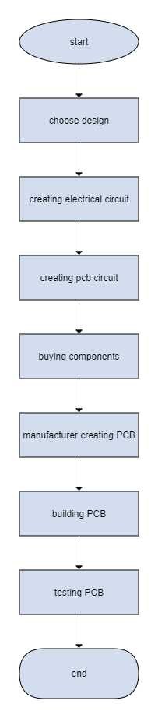

To start the project, the design “MicroSupply” was picked from one of the Elektor magazines or from the internet [1]. After reading the documentation about the MicroSupply, the electrical circuit is made by connecting all the 90 components with the corresponding voltages and components. The resistors and capacitors are divided into through-hole and Surface-mounted device (SMD) mounting types. The SMD types are mostly used in this design, but when the components are not available in SMD type, the through-hole is used. There are also microprocessors used in the design. The footprint of the components is mostly of type 0805. The program Altium is very useful for this because it has all the functions needed to create it [2].

Finding the components on Altium was hard, because not every component had the corresponding footprint or download files available. The footprint is needed to match the components used, so the components fit and the soldering can be done easily. The download files are needed to create a part library with all the 3d files and the footprints. This took more than 2 weeks to do because of the search for all the download files.

The next step was to convert the electrical design to a PCB design. Here, the connected components need to be arranged and the connections between the components must be made choosing between the top layer (red tracks) and the bottom layer (blue tracks). During the design process, the program checks for errors and reports them to the user. After this is complete, the PCB is exported to a readable file and given to the manufacturer to produce the design.

Figure 1: flowchart

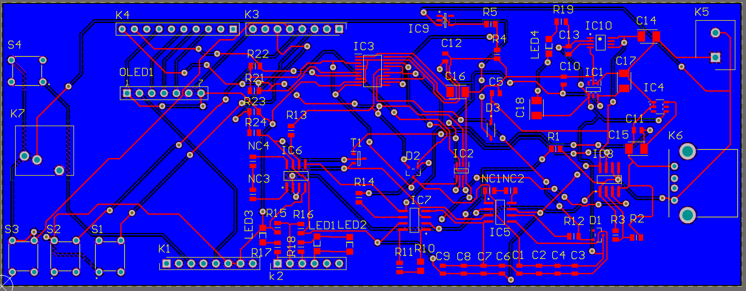

Figure 2: PCB design

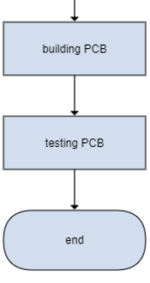

After the electrical circuit was created, the components needed for the design were purchased from 3 different websites because some websites did not have all the needed parts. The websites used are Mouser, Reichelt and Banggood and the delivery time is 1-2 weeks. There is an Arduino UNO used that is bought from the official Arduino website used in this design. The software used to run the Arduino is given by Elektor themselves. [3]

For the end result, a casing must be made for the design. The program used to make this is AutoCAD. AutoCAD is a computer-aided design (CAD) software that designers rely on to create 2D and 3D drawings [4]. The casting of the design must include a personally created logo. There is also other CAD software available like SOLIDWORKS CAD 3D but this software is not used by our school education.

The next step was to solder all the components on the PCB. First, the SMD solder paste got applied on the PCB using a stencil with holes in the right places to let the paste through on the footprints of the SMD components. Now, the SMD components are placed in the right places and then put in the oven to harden the solder paste. The rest of the components are soldered with a normal soldering iron.

Figure 3: flowchart



Figure 4: BOM MicroSupply

# Results

[Describe the end result you accomplished.

* Describe every aspect of your device. How does it function?
* Add an image of the electrical schematic, PCB design, finalized mechanical design, and finalized product

Write a well-structured text using subtitles and paragraphs.

**+/-500**]

## functionality

### Block diagram

A digital/analog converter (DAC) provides the adjustable supply voltage for the device. Because this converter cannot resist a lot of electrical current, a small power amplifier is added which allows a maximum amount of 40mA electrical current. The current at the load (outage current) can be measured by measuring the voltage drop over the shunt resistor.

The voltage across the shunt resistor first passes through several instrumentation amplifiers before it gets converted to a digital signal. The device uses 3 different instrumentation amplifiers because the current to be measured can vary from 1µA to 40mA. The smallest current is 40 000 times smaller than the biggest current which makes it hard to measure the desired precision with 1 measure range.

With an analog to digital converter (ADC), the voltages on the output of the 3 instrumentation amplifiers get converted from analog to digital. Lastly, the output voltage and current are displayed on an OLED display. The display is also used for displaying notifications and instructions when connecting.

The picture below is a simple representation of how the device works.

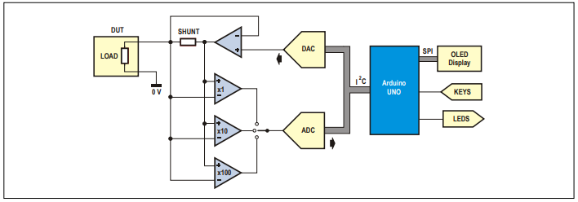

Figure 5: Block diagram

### Electric scheme

Gain factors of, for example, 1x for the large current, 10 x for the middle area, and 100x for the small currents make it possible to measure both small and large currents with the same precision. These 3 amplifiers (IC5, IC6, IC7) are put in parallel connection with different gain factors.

A digital to analog converter (IC2) is used to provide an adjustable voltage from 0 to 5 V. The converter has a reference voltage of 2.5 V and a resolution of 12 bits, the converter can supply an output voltage of 0 to 2.5 V in steps of 0.61 V. To obtain a voltage of up to 5 V, an OPAMP with a gain factor of 2 is used (IC8a). Now, the step size is 1.22V.

So that the output voltage does not depend on the output devices current, an intermediate coupling loop is made around the shunt resistor. An OPAMP with a boosted output is used to keep the voltage on the output constant. The input voltage of the MicroSupply is a minimum of 10V (9V plus the voltage across D3 and T1) and a maximum of 12V because of the maximum voltage across IC8 of 12V.

One of the most important components is the microcontroller. The microcontroller is a chip positioned on the Arduino UNO. the microcontroller controls the display of measured currents on the OLED display, controls the shield and makes the MicroSupply communicate with a PC via a serial USB port. [3]

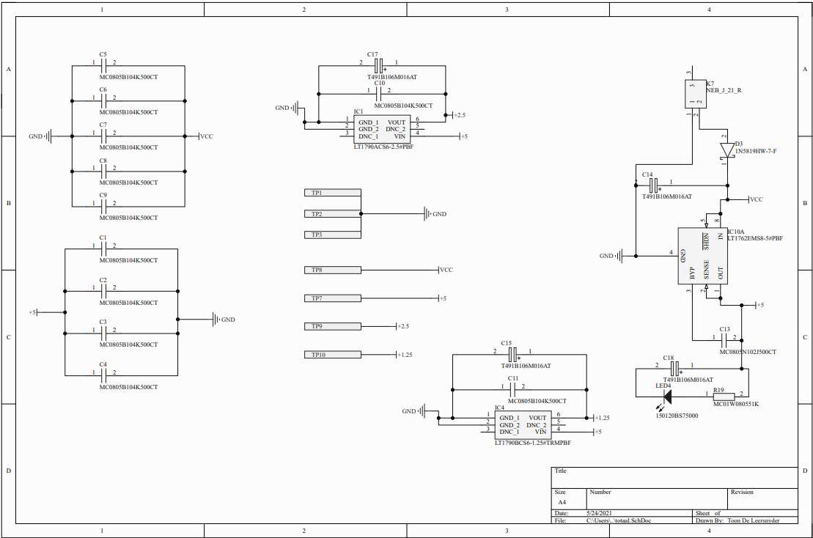

Figure 6: electrical schematic part 1

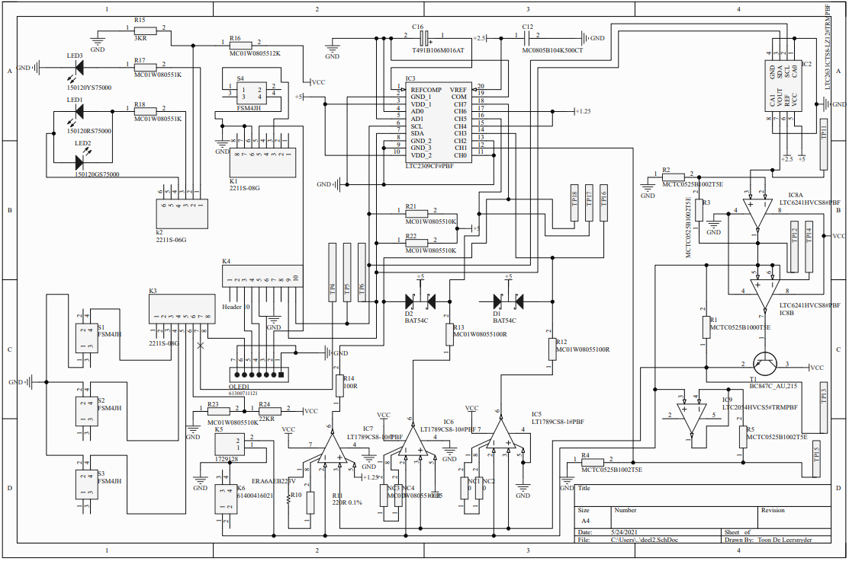

Figure 7: electrical schematic part 2

## usage

### functions

The MicroSupply has 3 stages:

* Stand-by: this mode is activated and deactivated with S1 (the rightmost push button). In this mode, with the push of buttons S2 and S3 (‘Down‘ and ‘Up’) the output voltage can be set in steps of 0,05 V between 1,5 and 5 V. The increase or decrease of the voltage can be accelerated by keeping the button pressed.
* Local: The readings are displayed on the OLED screen and not sent through the serial port. If you send the letter "E" via the PC program, this mode will be activated.
* Remote: The readings are sent through the serial port and not displayed on the OLED screen, the OLED screen displays "serial". If you send the letter "B" via the PC program, this mode will be activated.

LEDs and push buttons:

* LED1 (green): the IoT-device is receiving power.
* LED2 (red): the software switch is activated, the IoT device is switched off.
* LED3 (yellow): flashes when the IoT device is receiving power. At a program failure, the LED is continuously on or off.
* 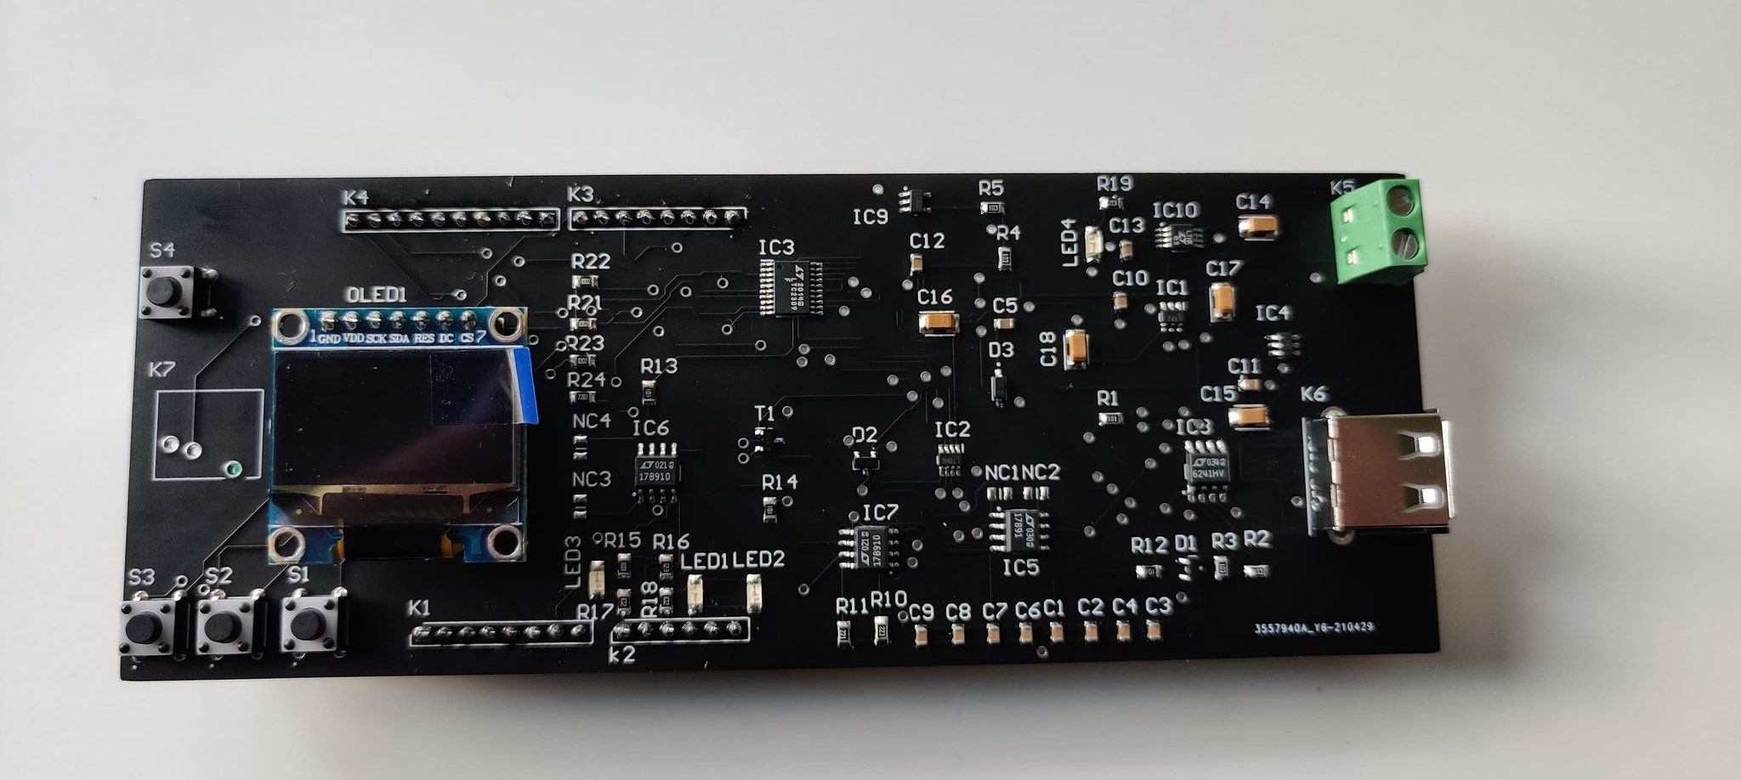LED4 (blue): the shield receives an external power supply. (That does not mean that this voltage is high enough.)

Figure 8: finalized product

* S1: activate / deactivate the output.
* S2: Up / Next / Yes
* S3: Down / No
* S4: Reset.

# Discussion

[Reflect on and discuss your project.

* Which difficulties did you encounter during the design process and why? How did you solve these issues?
* Reflect on the process: did things go as expected? Would you choose the same approach if you had to do the project all over again? Are there issues that still need to be fixed? How come?

**+/-300 words**]

The difficulty of creating a PCB is drawing the electrical diagrams, because the right components have to be found and connected together. When creating the PCB design, connecting the components was difficult due to the lack of space and because of the amount of components, a lot of vias had to be used to go from top layer to bottom layer. A few of the settings of Altium were wrong and because of this, the PCB design had to be recreated, which wasted a lot of time.

Tuning the case of the PCB to use the buttons and ports is precision work and thus takes a lot of time. When creating the electrical diagram, a resistor was forgotten and so it is not on the PCB, the device may not work. At the footprint of component K7 (power jack), there is an error that prevents the power jack from being soldered to the PCB, the solution found for this was to solder small wires to the connection pins of the power jack and then connect the wires to the footprint on the PCB. The delivery time of the PCB ordered from the manufacturer was longer than expected and caused a delay, an earlier order would have been better. Due to lack of time and covid19, the mechanical design cannot be realized.

# Reference list

|  |  |
| --- | --- |
| [1] | „Elektor magazines,” Elektor, [Online]. Available: https://www.elektor.nl/products/magazines. |
| [2] | „Altium designer,” Altium, [Online]. Available: https://www.altium.com/altium-designer/. |
| [3] | „Elektor,” Elekrot, 2019. [Online]. Available: https://www.elektormagazine.nl/magazine/elektor-112/51099. [Geopend 02 2021]. |
| [4] | „Autocad,” autodesk, [Online]. Available: https://www.autodesk.be/nl/products/autocad/overview?term=1-YEAR. |